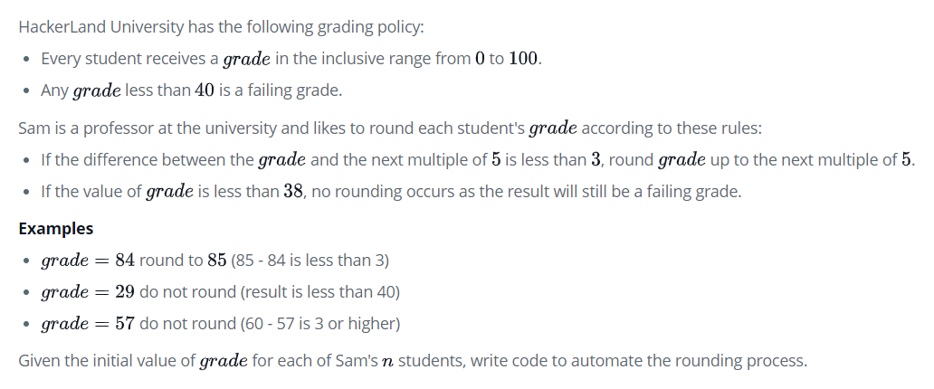

l2=[]

**for** i **in** grades:

**if** i>=38:

**if** i%5==4:

                l2.append(i+1)

**elif** i%5==3:

                l2.append(i+2)

**else**:

                l2.append(i)

**else**:

            l2.append(i)

**return** l2